**Ideation Phase**

**Brainstorm & Idea Prioritization Template**

|  |  |
| --- | --- |
| Date | 05 October 2022 |
| Team ID | PNT2022TMID47580 |
| Project Name | Smart Solutions for Railways |
| Maximum Marks | 4 Marks |

**Brainstorm & Idea Prioritization:**

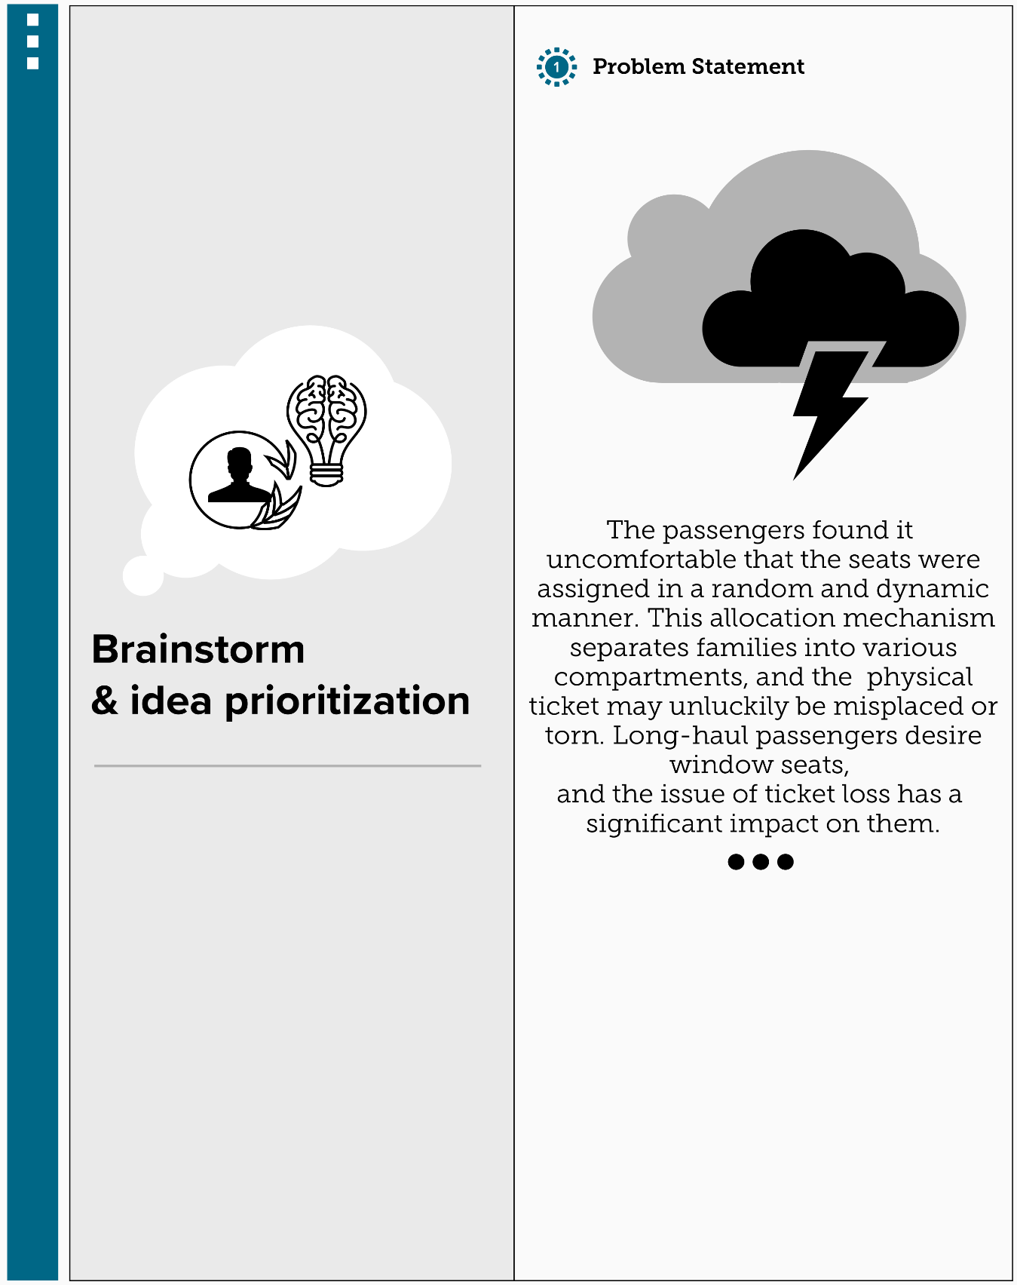**Step-1: Problem Statement**

**Step-2: Brainstorm**

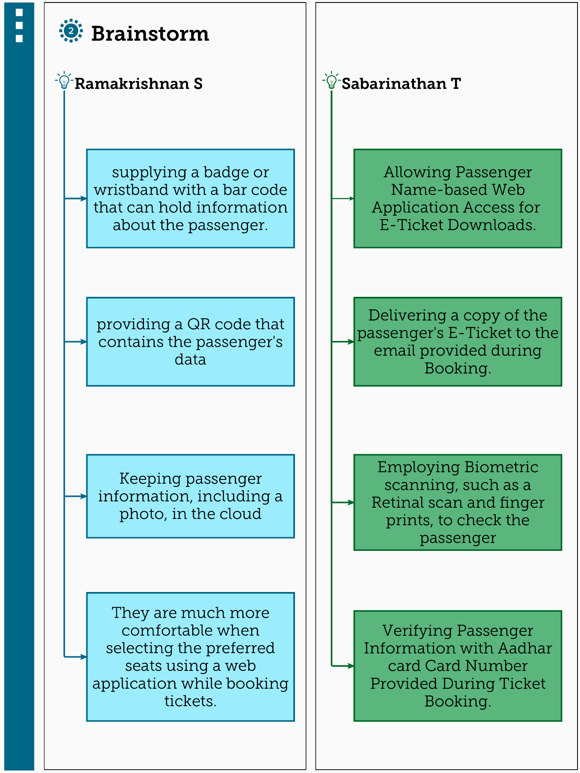

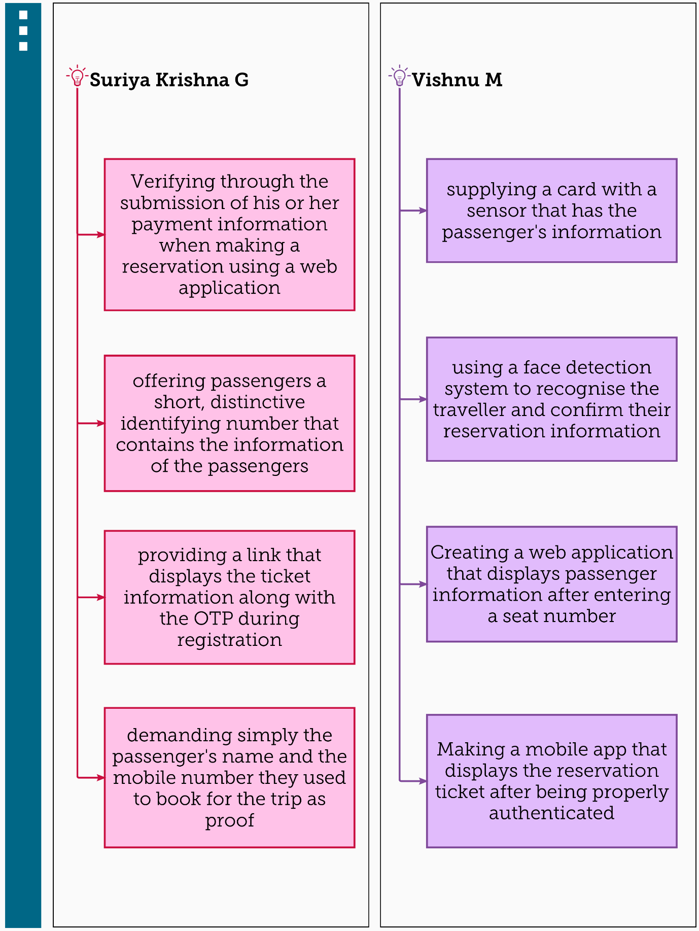

**Step-3: Idea Grouping**

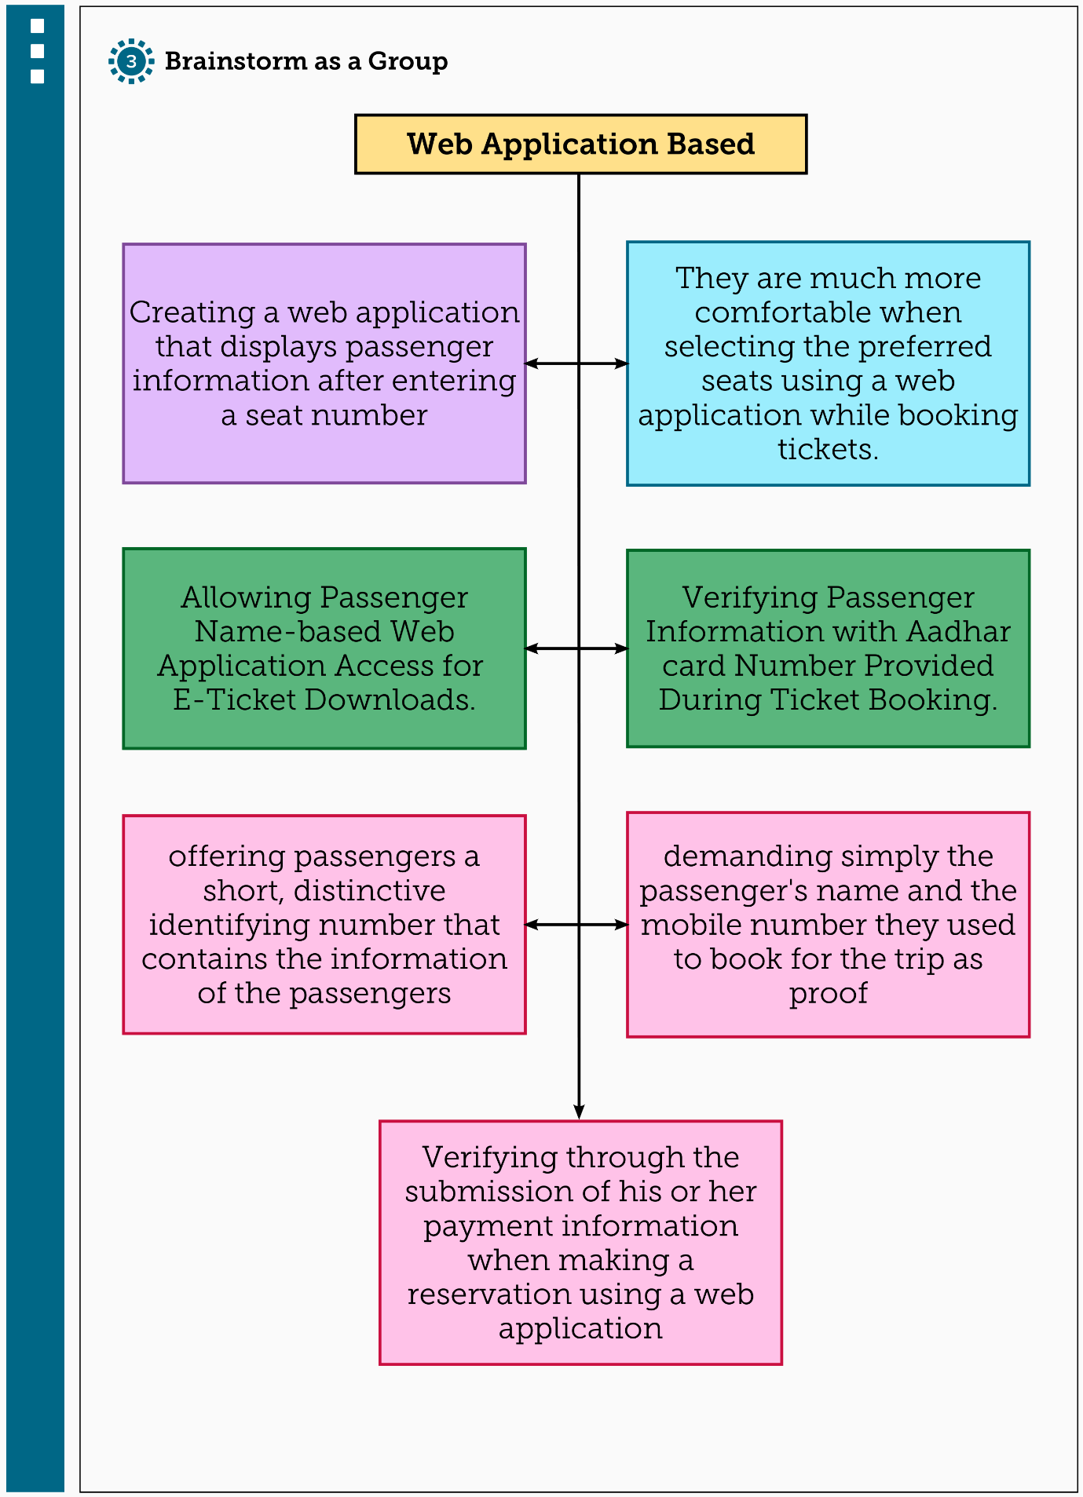

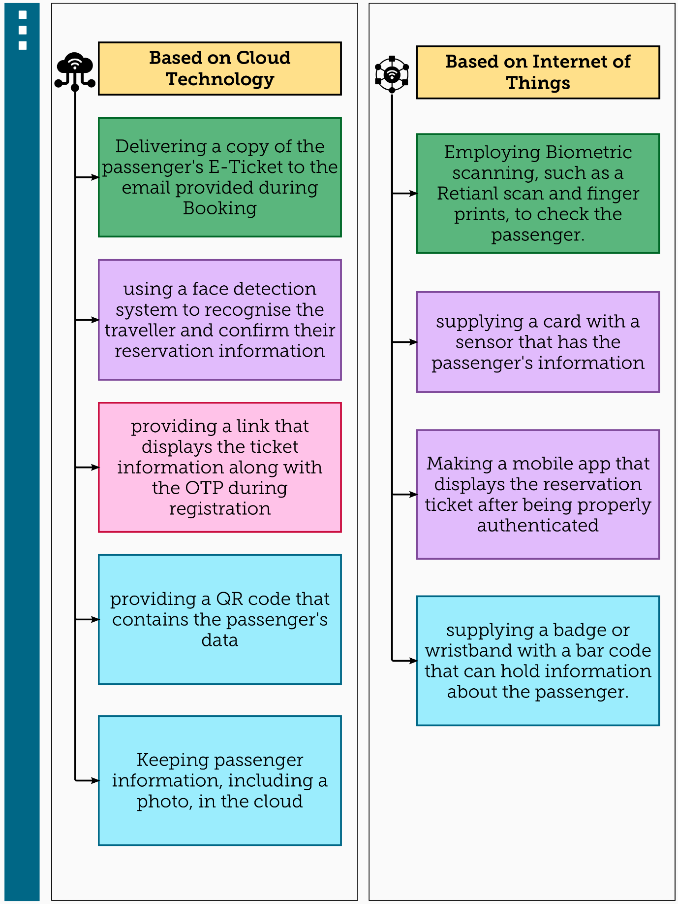

**Step-4: Idea Prioritization**

